**Organizational Chart of the Calorie Tracker:**

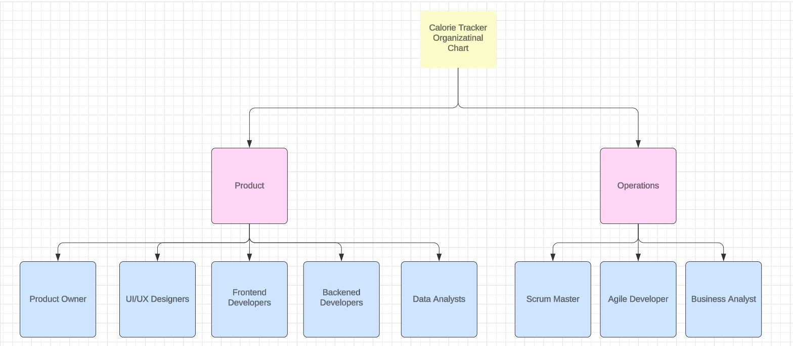

An organizational chart for a website that tracks calories is depicted in the image above. It adheres to a common structure found in many IT organizations that adopt Agile development processes. Here's an overview of the roles:

* **Product**: The calorie tracker website's general vision and direction are the responsibility of this team.
  + Product Owner: The product owner makes the ultimate choice on what features are produced and when. They collaborate closely with the other teams to guarantee that the website satisfies the needs of its users.
* **Operations:** This team is in charge of the website's day-to-day operations, which include ensuring that it is up and operating and that any issues are resolved as soon as possible.
  + Scrum Master: The scrum master is a facilitator who keeps the Agile development process on track. They remove any barriers to progress and guarantee that everyone on the team communicates well.
  + Agile developers: They use short sprints to swiftly provide new features and problem fixes. They are in charge of writing the code that makes the website work.
  + Business Analyst: The business analyst collaborates with the product owner to understand the business's needs and translate them into requirements for the development team.
* **Design:** This team is in charge of the calorie tracker website's appearance and layout.
  + UI/UX Designers: UI/UX designers are responsible for providing an easy-to-use user interface (UI) and a pleasant user experience (UX).
* **Development:** This team is in charge of creating the calorie-tracking website.
  + Frontend Developers: Frontend developers write the code that creates the website's user interface. This is the section of the website where users engage directly.
  + Backend coders: These programmers create the code that powers a website's backend. They are in charge of things like storing data in a database and ensuring that the website communicates with other systems properly.
  + Data Analysts: These professionals gather and examine information regarding user behavior on websites. This information is used to improve the website's usability.